BIO 110: Integrative Biology 1
SUMMER 2021
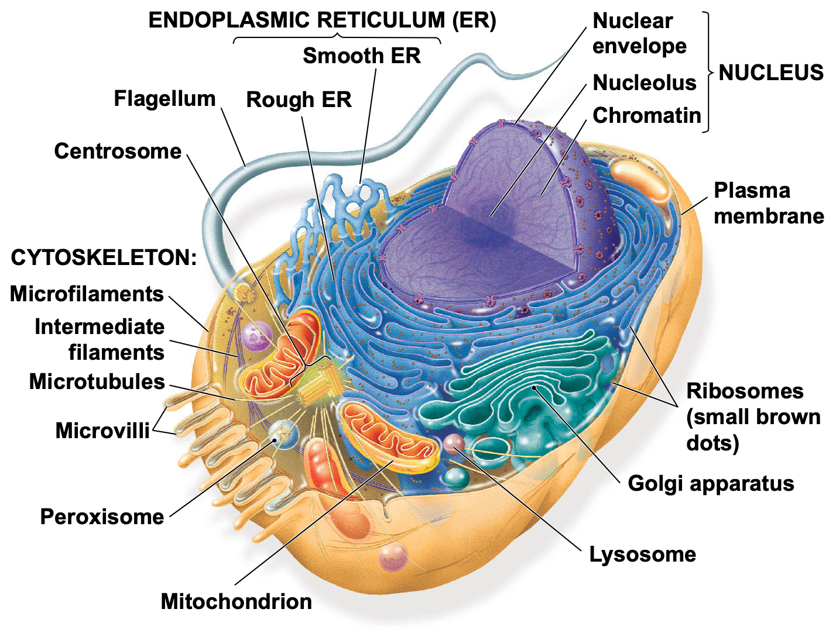

Classroom: Zoom – synchronous
Meeting ID:
Passcode:
**You must use your Agnes Scott Email to log into the zoom

Dr. Jennifer Larimore
Website: ilovebrains.org
LinkedIn: Jennifer Larimore
Email: jlarimore@agnesscott.edu
Office: 201 West BSC
Office hours: Office hours: Zoom Appointment Only; On Canvas, in the calendar section for this class, there are zoom appointments. You can sign up as you need them.

Course Overview

Course description: In this course, we will explore a number of core topics in biology including biochemistry, cell biology, genetics, gene expression, evolution, and ecology. Biology is a rapidly growing and expanding discipline. Because biologists are discovering new things every day, we have selected some of the most significant topics to cover in this course.

Course objectives: The American Association for the Advancement of Science - with support from National Science Foundation - described the concepts and competencies that form the necessary foundation for science majors (Vision and Change in Undergraduate Biology Education: A call to Action. ISBN#: 978-0-87168-741-8). The objective of Biology 110 is to cover these concepts through our topic explorations and exercise these competencies through assignment.

Concepts: 1. Evolution 2. Structure and Function 3. Information flow, exchange, and storage 4. Pathways & transformations of energy and matter and 5. Systems
Competencies: 1. Apply the process of science 2. Use quantitative reasoning 3. Use modeling and simulation 4. Tap into the interdisciplinary nature of science 5. Communicate and collaborate with other disciplines and 6. Understand the relationship for science and society

Skill Objectives – Skills you will gain from this course that advance your development as a scientist (and you can put on your CV and personal statements).
- Critical thinking/Problem Solving – through weekly in class application of knowledge and through analyzing papers, students will develop their ability to think critically about potential solutions to scientific questions.
- Written Communication – through the in class assignments, students will develop the ability to write scientifically.
- Teamwork/Collaboration – working with a team for in class assignments will enable the students to practice real-world teamwork and leadership.
- Digital Technology – students will learn how to navigate various online resources to complete assignments and collaborate with peers. Students will actively use Canvas, PubMed, Google Drive and Power point.

How to Do Well in BIO 110

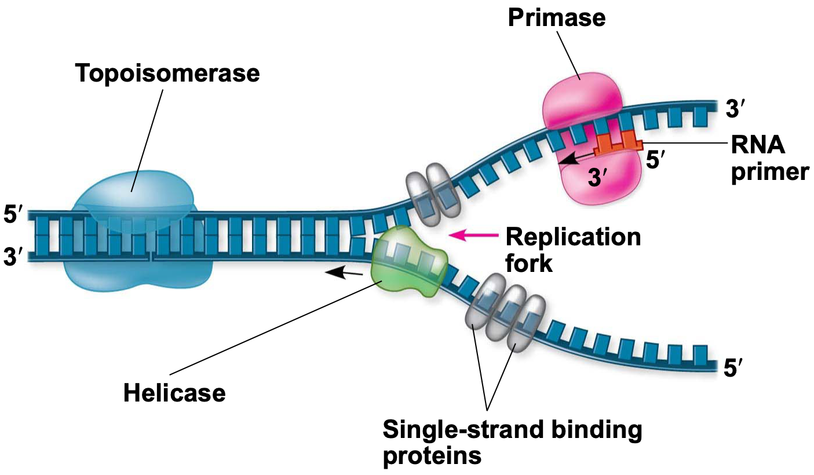
Identify the purpose and plan. Why are you taking this class? What purpose does this class serve for you? What are your personal goals for this class? What will it take to achieve these goals? Why are these goals important to you? You need to be able to answer these questions for each class you take – because the work will get hard and you will need to remind yourself what you are aiming for at the end of the semester. Set your goal and then make a plan to achieve that goal. Post that goal in your course text or notebook.
Good Habits: Learning throughout the semester: Preparing for tests and actually learning the material in Bio 110 and every other class you’ll take, for that matter is made infinitely easier and more enjoyable if you establish an organized system for approaching the lecture and reading material early on in the semester.

SCHEDULE time and STICK to it: Based on assignments for both lecture and lab, you will spend 8-10 hours studying for this class outside of class time. Please come see your instructor early in the semester if you are struggling. The lecture portion of Biology 110 is a 3 credit course. Additionally, you need to be co-enrolled in the 1 credit Biology 110 lab.

Add time to your Google Calendar each week for this course. Those time slots will vary based on your level of understanding, but in general, they should be about an hour each.
(1) read the assigned reading and take notes on it,
(2) listen to the lecture and take excellent notes,
(3) complete the DRQ ahead of time in case you have questions you need to ask before submitting it,
(4) to meet with your study group to review the lecture and prepare for the quiz. Each lecture topic should have 4 time slots,
(5) to complete the bigger projects. Schedule several different time slots for the semester projects/assignments to give yourself plenty of time to work on these assignments (and so they don’t sneak up on you).

Do not change those times. Make those times a habit - time that is carved out for this class and your success.
Grades

Your grades will be posted to Canvas regularly so you are aware of your standing in the course. Your final grade will be calculated using the following point breakdown:

Use of Sources Assignments 5 points
CV/Personal Statement 10 points
Quiz Grade 55 points (12 quiz x 5 points each, dropping the lowest quiz grade)
Test Points 250 points (3 50 point tests and 1 cumulative final (100 points))
In Class work 55 points (12 activities x 5 points each, dropping the lowest grade)
Total points: 375 points total *Your instructor may assign additional points

The following grading scale will apply for converting numerical grades into final letter grades:
93 to 100: A, 90 to 92.9: A-, 87 to 89.9: B+, 83 to 86.9: B, 80 to 82.9: B-, 77 to 79.9: C+, 73 to 76.9: C, 70 to 72.9: C-, 67 to 69.9: D+, 63 to 66.9: D, 60 to 62.9: D-, Lower than 60: F

**your grade is not weighted. Your grade is calculated by total points earned divided by totals points possible, multiplied by 100. You can simply add the total points you earned so far and divide by the total points possible so far. Multiple that number by 100 to get your grade currently in the class. You can also use the same math to figure out what you need to get on a test in order to pull your grade up.

Before Class

1. READ the assigned chapter (see syllabus schedule, or the ARQ/DRQ for that lecture, or the date on the calendar when that lecture will be discussed). The chapter will contain material that is explained differently and supports the lecture. Read and take notes on the chapter (not just highlight) prior to listening to the recorded lecture. Hand-written notes will allow you to retain the information more than highlighting or simply reading. When you read, don’t look at your phone or email. Focus on what you are reading. Bring those notes to class.

2. LECTURE: Open the lecture PDF and create an outline for note taking before listening. Listen/watch to the assigned lecture MP3 file for that topic (available through a link on Canvas) and minimize distractions so you can pay attention. While listening, take notes – putting information in your own words. Add notes from the chapter. And bring those notes to class. If you have questions regarding the lecture or chapter, feel free to email your professor before class or talk with the learning assistants assigned to this class. You can also talk to your team about any questions you have. But you are responsible for the information in the lecture and the chapter for the quiz.

*Why did we record the lectures? Science education after college will require you to teach yourself the information. With a flipped classroom, you will begin to learn that skill. Medical schools and graduate schools will expect you to come to class knowing much of what was assigned in reading and your class time will take that information further. To prepare you for that type of learning, we have recorded the lectures. This allows you to take the lectures at your own pace. Everyone can get through the lecture - the person who has had AP Biology and the person who didn’t have any biology in high school can listen at their own pace and get the same information out of the lectures. Further schooling won’t necessarily give you lectures. Because this is college and not graduate school, we have provided these recorded lectures as an aid so you can learn how to study and teach yourself these topics.

3. Complete the ASSISTED READING QUESTIONS (ARQs) or Directed Reading Questions (DRQs) which are based on the assigned readings and the lecture. Answer the questions after you listen to the recorded lecture and after you complete the reading assignments. This will help you review what you know and what you need to review (consider using these questions as a test of what you know. They will allow you to focus on what the professor feels is important.

4. QUIZZES. Before your class, you will take a lecture quiz online. Quizzes will be open 48 hours prior to class. You will have 30 minutes to take the quiz. This quiz will cover the recorded lecture material and assigned chapter material. There will be no make-up quizzes. Your lowest quiz grade will be dropped. Quizzes will allow you analyze your knowledge, practice the type of test questions - all so you can prepare best for the upcoming tests. They are application questions, multiple choice. Do not use your notes or book for the quizzes.

Class Time

GROUP IN CLASS ACTIVITIES are meant to practice and apply what was learned in the lecture. These will be completed in teams during the lecture time and turned in on Canvas and graded as a group. Because this will be completed in break out rooms in Zoom, I will not be recording our Zoom sessions. If you are not present, you will be given a 0 for that in class assignment. If you have to miss a class, email me PRIOR to that class and we can arrange something. Use your notes, your ARQs and your book. Being able to apply what you learned through the lectures will be necessary to remember the information for your time in BIO 111, your upper level courses, and for your science career. In class activity will be due 24 hours after lecture.

Here are some tools for analyzing primary literature. Take what is useful to you.

https://www.huffpost.com/entry/how-to-read-and-understand-a-scientific-paper_b_5501628 (Links to an external site.)

https://web.stanford.edu/class/cs244/papers/HowtoReadPaper.pdf (Links to an external site.)

https://www.ncbi.nlm.nih.gov/pmc/articles/PMC3687192/ (Links to an external site.)

https://www.sciencemag.org/careers/2016/03/how-seriously-read-scientific-paper (Links to an external site.)

Assignments and Materials

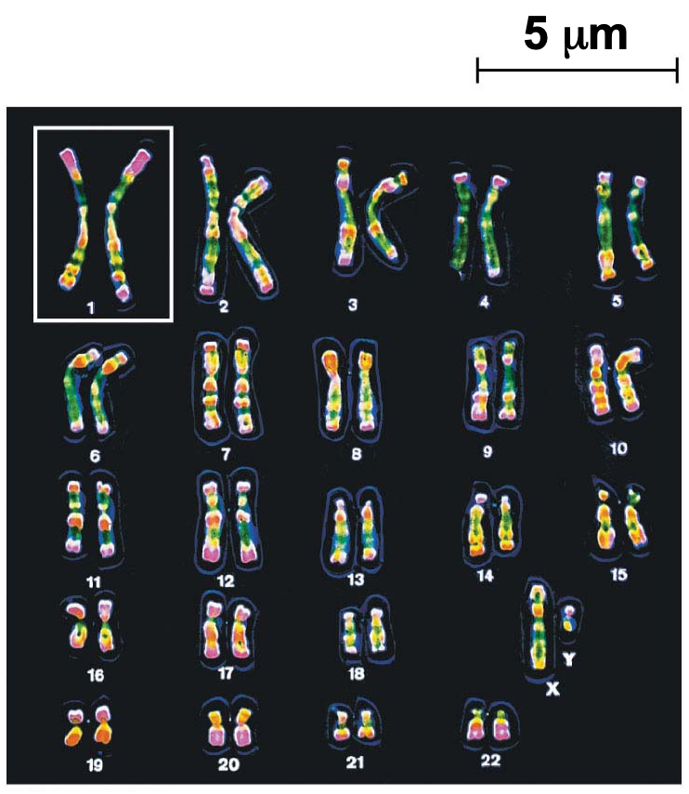
- Use of Sources Assignment
For this assignment, you will need to read the following: Knowing and Avoiding Plagiarism During Scientific Writing P Mohan Kumar, N Swapna Priya, [...], and M Nagasree. There is a series of questions to answer after you read the article. The due date will be posted to Canvas which is where you will upload your answers. This is individual work.
- Science Career PDF
Available to you on Canvas is a PDF called “Guide to Life Science Careers”. If you have questions of want to talk about some of the careers, let your professor know.
- CV or Resume and Personal Statement
This assignment is meant to ensure that what you learn in this class is reflected in your career documents. There is a “how to” document and a template on Canvas.

Tests

Tests will consist of multiple choice and short-answer questions that evaluate your knowledge. They will be application questions. The final exam will be cumulative. See schedule for test dates. All of the tests will be online.

Test Tips:
Developing good study strategies early on will save you lots of time and frustration over the next four years and beyond. You may find that the way you studied in high school doesn’t work as well in college, where exams test whether you can apply and extend what you’ve learned rather than regurgitate minute details. A small amount of time every day is more effective than late-night marathon sessions. If a longer, intensive study session is needed, do it two nights before a test to guarantee a full night’s rest.

1. Form a study group: Study groups, if well structured, can be the most effective and time efficient way to review. Some tips on how to make a great study group: Size: Study groups that are too big tend to get disorganized, and if some students are more comfortable with the material than others some may not get all their questions answered. Most students find groups of 2 to 5 friends works best. Prepare: It’s important to review the material before coming to a study group. This could merely be skimming your notes to identify confusing areas, but you should make a list of questions to bring to the group. Organize: Assign each person a specific section (topic, lecture, etc.) to study and explain to the group. If you have to explain something to a group, you are sure to understand it. Group dynamic: Don’t let one person dominate the conversation or get sidetracked by other distractions.

2. Start studying early: Review notes and make a study guide. Have an organized system for reviewing your notes. Here's my own personal strategy: Outline lecture notes: Read through your class notes and write down main ideas in outline form, including some specific details that you think you’ll forget. I like to put these study guides together at the end of the semester to make studying for the final easier. Color-coding (by topic or importance) is also useful.

Use textbook/reading notes: If you see anything surprising or particularly relevant to lecture material, or find a useful diagram, reference it in the margin of your lecture notes outline.

Flashcards: Use flashcards with vocabulary from the DRQs and the chapter as well as some basic questions to quiz yourself.

Draw your own diagrams: After studying your lecture notes, try to tie the material together by putting it in picture form (without looking at your notes.)

Write your own test. If you had 20 (or 50, or 100) questions that you could ask about this information – what would you ask? What topics are the most important? How would you ask questions about each of these topics? Knowing what will be on a test is a difficult skill – but, with practice, you should be able to figure it out.

Review all your lab notes. Labs and lectures are intended to overlap. Lab may be a space that can help shed light. Lectures Your instructor is the one giving the exam, so pay close attention to what they find most important and interesting. ARQs/In Class Activities Review all your material for the section. Your assignments cover the topics your instructor believes to be most important.

3. AFTER studying: Do practice problems and textbook questions. Go to review sessions. Bring questions when you go to a review session; otherwise, it will be a waste of time. Explaining the material to friends is one of the best ways to study and identify the things you don’t know.

4. After the test: It's not over yet! Some things you should do after an exam: Review questions you got wrong, talk to the professor if you’re unhappy with your grade and save study guide to build on all semester.

Academic Honesty

You are responsible. You are expected to read the article and complete the assignment (see schedule for due date): Knowing and Avoiding Plagiarism During Scientific Writing by P Mohan Kumar, N Swapna Priya,1 SVVS Musalaiah, and M Nagasree. Ann Med Health Sci Res. 2014 Sep-Oct; 4(Suppl 3): S193–S198. If you have any questions about that article, please email your professor.

By placing your name on ANY assignment, you are stating that you completed that assignment with academic honesty. Cheating in this class may keep your grade where you want it, but it will not help your career long term – you cannot cheat the GRE or the MCAT. You have to learn this material in order to succeed in science. Additionally, academic dishonesty is reported to medical schools and graduate schools as per their request. Finally, anyone caught cheating relinquishes the privilege of asking for a letter of recommendation from the professor and will receive a 0 on the assignment.

Plagiarism: do attribute all ideas taken from other sources; this shows respect for other scholars. Plagiarism can include portraying another’s work or ideas as your own, buying a paper online and turning it in as if it were your own work, or not citing or improperly citing references on a reference page or within the text of a paper. Passing off someone else’s work as your own represents intellectual fraud and theft, and violates the core values of our academic community. Plagiarism is passing off any work that is not yours as your own work ** EVEN WITH A CITATION***. If you are using a source and citing the source, the information from that source STILL must be reworded in your own voice. Putting a citation behind a statement gives ownership to that source, but, if you do not reword that information, it is plagiarism. Do not cut and paste from the slide, your book, your neighbor, Wikipedia, or the internet. To further your science education, you need to be able re-word science in your own voice. If your answers are not your own, you will receive a 0 for the assignment.

Intellectual Fraud: do not falsify or create data and resources or alter a graded work without the prior consent of your professor. This includes making up a reference for a works cited page or making up statistics or facts for academic work.

Cheating: do not allow another party to do your work/exam, or submit the same or similar work in more than one course without permission from the course instructors. Cheating also includes taking an exam for another person, looking on another person’s exam for answers, using exams from previous classes without permission, or bringing and using unauthorized notes or resources (i.e., electronic, written, or otherwise) during an exam. Cheating also includes when you help another student complete a take home exam, give answers to an exam, talk about an exam with a student who has not taken it, or collaborate with others on work that is supposed to be completed independently.

Class Management

Email: Instructors will make announcements regularly via email. It is your responsibility to check your Agnes Scott email account daily. When responding to a professor via email, take care that your email is professional.

Canvas: You can access the calendar in Canvas. And that calendar can be shared with your Google Calendar. There is a discussion board where you can use the class to answer questions or get in touch with the professor. The modules contain each of the pieces of the course. The syllabus item lets you see this syllabus and the schedule.

Course evaluations: At the end of the semester you will receive an email asking you to submit an evaluation of the course. Please give feedback! Your input is important to the college as a whole and to us as instructors. We take your comments very seriously.

ADA: Agnes Scott College seeks to provide equal access to its programs, services and activities for people with various abilities. If you will need accommodations in this class, please contact the Office of Academic Advising and Accessible Education (404-471-6150) to complete the registration process. Once registered, please contact me so we can discuss the specific accommodations needed for this course.

Title IX: For the safety of the entire community, any incidence of or information about sexual misconduct must be reported immediately to Title IX Coordinator Marti Fessenden (mfessenden@agnesscott.edu, 404-471-6547).

Inclusion: This course adheres to the principles of diversity and inclusion integral to the Agnes Scott community. We respect people from all backgrounds and recognize the differences among our students, including racial and ethnic identities, religious practices, and gender expressions. We strive for our campus to be a safe space in which all students feel acknowledged and supported. At the same time, we understand that course content, critical inquiry, and classroom dialogues give us opportunities to examine topics from a variety of perspectives. Such discourse is a defining feature of a liberal arts education, and can compel debates that challenge beliefs and positions, sometimes causing discomfort, especially around issues related to personal identities. While we uphold and preserve the tenets of academic freedom, we request and invite your thoughtful and constructive feedback on ways that we can, as a community of learners, respectfully assist and challenge one another in our individual and collective academic work.

Content warning: This course will explore cell biology, genetics, ecology and evolution, which might raise issues of racism, sexism, classism, heterosexism, cissexism, ableism, and other kinds of privilege. I invite you to come see me if want more information. If you feel you will be unable to fully participate in the course requirements, set up a meeting with the course instructor to determine appropriate accommodations.

