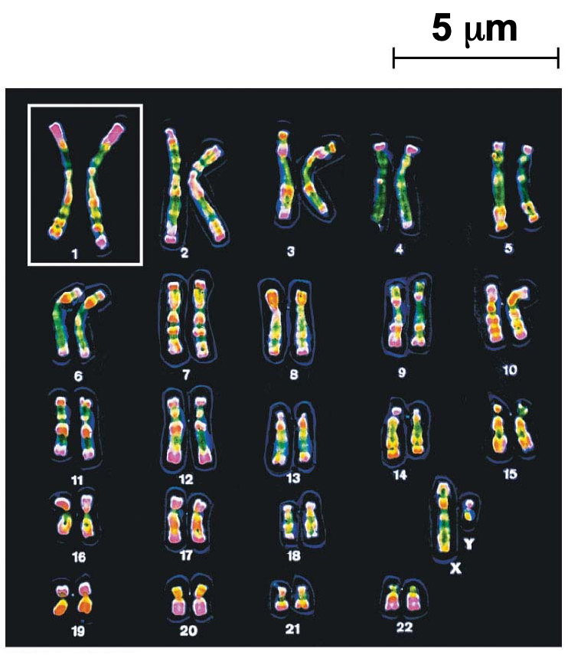
BIO 110: Integrative Biology 1
Fall 2023
Every Tuesday & Every Thursday
11:30 AM – 12:45 PM
210 East

Dr. Jennifer Larimore
Website: ilovebrains.org
LinkedIn: Jennifer Larimore
Email: jlarimore@agnesscott.edu
Office: 201 West BSC
Office hours: by appointment

SYLLABUS OUTLINE:

- Course Description and Textbook
- Success Plan
- Course and Skill Objectives (what you gain from the course)
- Grade Breakdown
- Course Overview
  - Reading
  - Lectures
  - Study Guides
  - Mastering Biology
  - Tests
  - Hidden Figures Presentation
- Academic Honesty
- Class Management

1. COURSE DESCRIPTION:
In this course, we will explore a number of core topics in biology including biochemistry, cell biology, genetics, gene expression, evolution, and ecology. Because biologists are discovering new things every day, we have selected some of the most significant topics to cover in this course.

The lecture portion of Biology 110 is a 3 credit course. Additionally, you need to be co-enrolled in the 1 credit Biology 110 lab.

- Textbook: Biology in Focus, Second Edition, Pesrson Publishing, by Lisa A. Urry, Michael L. Cain, Steven A. Wasserman, Peter V. Minorsky, Jane B. Reece. ISBN-13: 978-0321962751

This text is also used for Biology 111.
Any Format is Acceptable.
No Mastering Biology login required (we will not be using Mastering Biology)
- Posted to Canvas: PowerPoints PDF files, Unit HW files, and assigned scientific papers
- Canvas discussion board: use this to crowdsource explanations to specific questions
- Canvas syllabus tab lets you see this syllabus and the schedule for this course.
- Google Drive folder for this class: MP3s for the lectures are in the Google Drive - you must be using an Agnes Scott email address.
- Course Calendar in Canvas and share it with your Google Calendar. See:https://community.canvaslms.com/t5/Student-Guide/How-do-I-subscribe-to-the-Calendar-feed-using-Google-Calendar-as/ta-p/535
- Must have access to a computer or tablet. If you need help with this, visit ITS.
- Cell phones should NEVER be visible/used during class time and can result in tardiness (see rubric below).
- Email/Canvas: Instructors will make announcements regularly via email. It is your responsibility to check your Agnes Scott email AND Canvas page daily. When responding to a professor via email, take care that your email is professional AND that you identify what class you are in.

2. SUCCESS PLAN:
Purpose and Plan: Why are you taking this class? What purpose does this class serve for you? You need to be able to answer these questions for each class you take – because the work will get hard and you will need to remind yourself what you are aiming for at the end of the semester. Set your goal and then make a plan to achieve that goal. Post that goal in your course text or notebook.

Good Habits: Learning throughout the semester: Preparing for tests and actually learning the material in Bio 110 (not just cramming for tests) and every other class you’ll take is made infinitely easier if you establish an organized system for approaching the lecture and reading material early on in the semester.

Study methods are different for every student. Talk to your classmates and see what works for them. Visit the Resource Center for Math and Science (RCMS) to talk to tutors about great ways to study.

Based on assignments for both lecture and lab, you will spend 8-10 hours studying for this class outside of class time. Please come see your instructor early in the semester if you are struggling.
This course will require your active, regular participation in lecture times. You will receive 1 grade (60 points) for the entire semester for your attendance, participation, and quality of participation in class. See the rubric below, which will evaluate your entire semester.
 | Excellent  20 | Good Work  15 | Fair  10 | Below Average  5 | Poor  0
Semester Attendance | Attended all sessions or received approval for necessary absences | 1 unexcused absences | 2 unexcused absences | 3 unexcused absences | 4 or more unexcused absences
Semester Tardies | Was on time and did not leave early for all sessions and/or received approval for necessary altered hours | 1 unexcused tardy (came more than 5 minutes late or left more than 5 minutes early, or was on a website/app that did not contribute to class) | 2 unexcused tardy (came more than 5 minutes late or left more than 5 minutes early, or was on a website/app that did not contribute to class) | 3 unexcused tardy (came more than 5 minutes late or left more than 5 minutes early, or was on a website/app that did not contribute to class) | 4 or more unexcused tardy (came more than 5 minutes late or left more than 5 minutes early, or was on a website/app that did not contribute to class)
Semester evaluation of student’s contribution to class discussions | Engaged in the conversation.  Comments were almost always insightful and constructive. Comments were almost always balanced, using scientific terminology and showed critical analysis skills | Mostly engaged in the conversation.  Comments were mostly insightful and constructive. Comments were mostly balanced, using scientific terminology and showed critical analysis skills. Occasionally comments were too general or not relevant. | Partially engaged in the conversation.  Comments were sometimes insightful. Comments were sometimes balanced, using scientific terminology and showed critical analysis skills. Often comments were too general or not relevant. | Often inattentive in class.  Comments were infrequent and the student appeared inattentive. | Not engaged with the conversation - to others or make insightful comments.

3. COURSE OBJECTIVES:
The American Association for the Advancement of Science described the concepts and competencies that form the necessary foundation for all science majors.

Concepts 1. Evolution 2. Structure and Function 3. Information flow, exchange, and storage 4. Pathways & transformations of energy and matter and 5. Systems & Competencies 1. Apply the process of science 2. Use quantitative reasoning 3. Use modeling and simulation 4. Tap into the interdisciplinary nature of science 5. Communicate and collaborate with other disciplines and 6. Understand the relationship for science and society

Skill Objectives Skills you will gain from this course that advance your development as a scientist (and you can put on your CV and personal statements).
- Critical thinking/Problem Solving – through weekly application of knowledge and analyzing papers, students will think critically about potential solutions to scientific questions.
- Written Communication – through the final project, and in class assignments, students will develop the ability to write scientifically.
- Teamwork/Collaboration – working with a team for in class assignments will enable the students to practice real-world teamwork and leadership competencies that are taught as a part of SUMMIT.
- Digital Technology – students will learn how to navigate various online resources to complete assignments and collaborate with peers. Students will actively use Canvas, PubMed, Google Drive and Power point.

4. GRADES:
Your grades will be posted to Canvas regularly so you are aware of your standing in the course. Your final grade will be calculated using the following point breakdown:
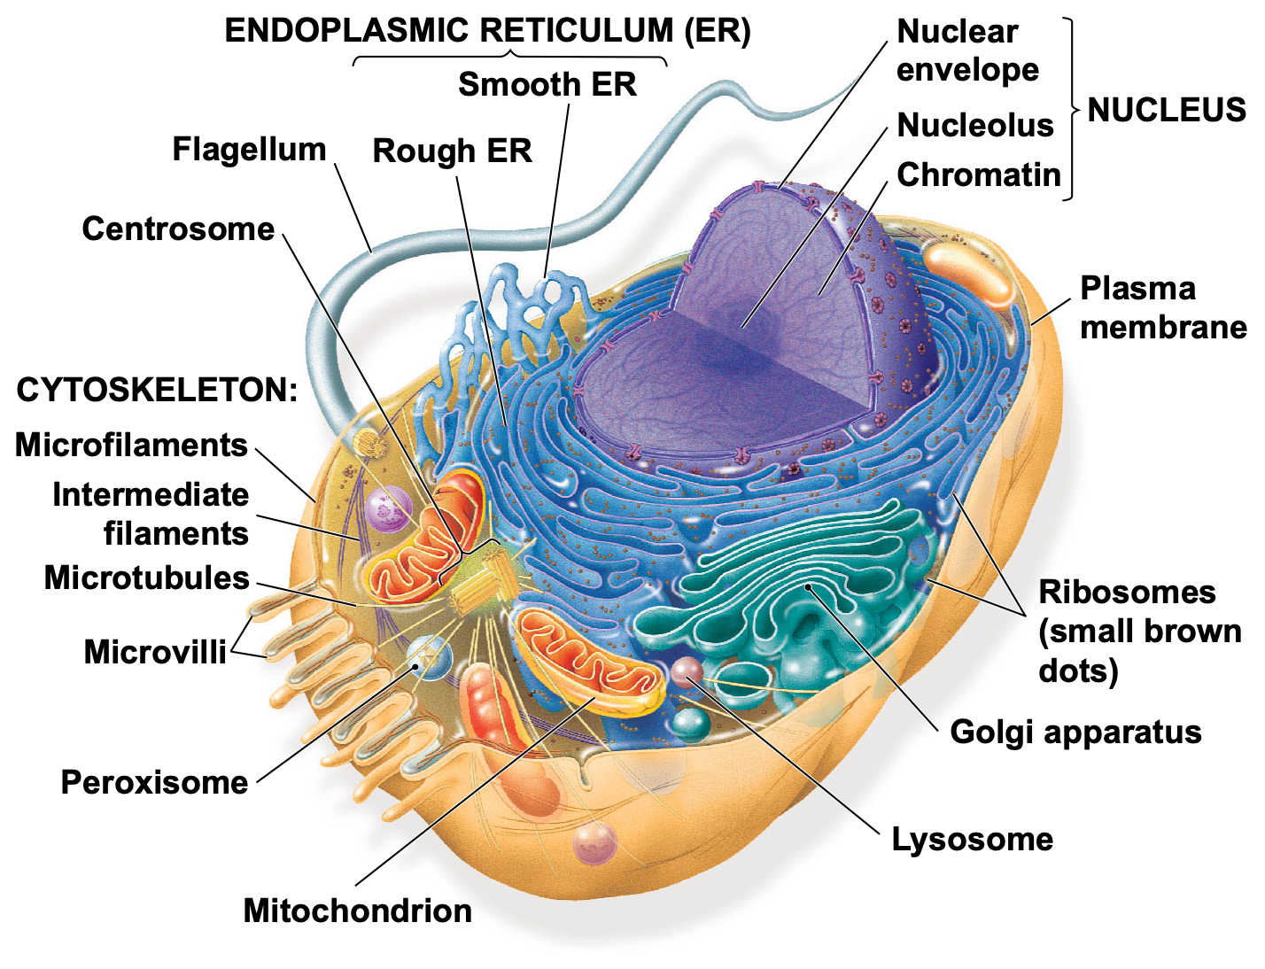
Syllabus Homework 10 points
Career Management Homework 15 points
Unit Homework Rubric 160 points (40 each x 4)
Attendance Rubric 60 points
Test Points 240 points (60 points each x 4)
Cumulative Final Exam 100 points

The following grading scale will apply for converting numerical grades into final letter grade: 93 to 100: A, 90 to 92.9: A-, 87 to 89.9: B+, 83 to 86.9: B, 80 to 82.9: B-, 77 to 79.9: C+, 73 to 76.9: C, 70 to 72.9: C-, 67 to 69.9: D+ , 63 to 66.9: D, 60 to 62.9: D-, Lower than 60:

**Your grade is calculated by total points you have earned divided by total points possible (445 points possible) , multiplied by 100.

5. COURSE OVERVIEW/COURSE EXPECTATIONS:
You may find that listening to the lecture before reading the chapter serves you best or the reverse may be true. Either way, the lecture PDFs are available on Canvas. Use these PDFs and the lecture outline to guide your concept maps (which are described in the Unit HW).

BEFORE CLASS:
(1) Read the assigned chapter and papers (see syllabus schedule). The chapter will contain material that is explained differently than the lecture and supports the lecture. Add the chapter material and the assigned article to your concept map BEFORE class.
(2) Listen to the recorded MP3 lecture for that material BEFORE coming to class for that topic. Add that material to your concept map BEFORE class.
Bring a copy (digital or printed) version of your concept map to in-class work. This will serve as a way to generate answers to the questions in class.

IN-CLASS WORK:
Practice and apply what was learned in the lecture. The in-class time will be spent on how to apply the knowledge - no simple definitions or fact memorization. In-class assignments will be completed in a group. There will be a paper handed out in class and you will keep the assignment as a study aid for the test. These assignments are not graded, but are similar to the questions on the test.

CONCEPT MAPS:
The concept maps will include the following material (see the rubric):
(1) Assigned reading (chapter and article) (see rubric for what is expected on the concept map)
(2) Article Analysis questions (see syllabus calendar for the specific questions for each Unit’s article questions)
(3) Lecture MP3 Material (see rubric for what is expected on the concept map)

There are many ways to organize the material in a concept map. Look at Canvas for examples from previous classes. Additionally, you can use the concept maps that are in the lecture. Concept maps are a type of graphic organizer that can help you make sense of difficult topics. Concept maps are visual representations of information. They can take the form of charts, graphic organizers, tables, flowcharts, Venn Diagrams, timelines, or T-charts.

There are many websites that allow you to create concept maps. Including google docs with limitless page dimensions. Here are a few:
https://slidesgo.com/slidesgo-school/google-slides-tutorials/how-to-make-a-concept-map-in-google-slides

https://www.lucidchart.com/pages/concept-map

Article Analysis to go on the Concept Map
Answer the questions below based on the assigned article - answer ONLY on your concept map. Each answer needs to show critical analysis of the paper. The answer to any of these questions CANNOT be a quote from the article or outside source. You cannot copy and paste from the article or outside source. You MUST rephrase any material. This is an exercise in becoming scientifically literate, which will require extra work on your part.

Material Covered: Unit 1, Campbell Chapter 1 - 4
https://kb.gcsu.edu/cgi/viewcontent.cgi?article=1024&context=undergraduateresearch
Unit #1 Concept Map Article Analysis Questions:
1. In this Unit’s assigned article, summarize the research question being asked (the hypothesis). On your concept map, put the title of the paper. And on your concept map, state the hypothesis beneath the title in your own words.
2. Why is the hypothesis a good hypothesis? (In other words, what makes a good hypothesis?) Add this to your concept map.
3. In the paper, DESCRIBE the experimental controls. DESCRIBE the experimental variables. Add this to your concept map.
4. Add Figure 1 in the Kareklas paper to your concept map. Explain what data you find on the x axis on your concept map. Explain what data you find on the y axis on your concept map. Overall, explain what the data in the graph tells us.
5. What do the stars above the graphs mean? Why are they important/of value to the graph? (you may need to use google to help answer this question)

Materials Covered: Unit 2, Campbell Chapter 9,10, 13, and 14
https://pubmed.ncbi.nlm.nih.gov/31349651/
Unit #2 Concept Map Article Analysis Questions:
1. On your concept map, describe the main points/key focus of the article.
2. On your concept map, list 5 key facts from the introduction that lead to the formation of the hypothesis in the paper.
3. Paste Figure 1 on your concept map. On your concept map, explain what technique was used to generate this figure. On your concept map, describe what the data mean. On your concept map, explain how the data from this figure support the hypothesis.
4. Paste Figure 7 on your concept map. Examining figure 7. On your concept map, explain what technique was used to generate this figure. On your concept map, explain what the data mean. On your concept map, explain how the data from this figure support the hypothesis
5. On your concept map, list the key results from each of the figures. On your concept map, explain if these results support the hypothesis and defend your answer.

Material Covered: Unit 3, Campbell Chapter 11, 12, 14, and 19
And https://pubmed.ncbi.nlm.nih.gov/11222644/
Unit #3 Concept Map Article Analysis Questions:
1. On your concept map, describe the main points/key focus of the article.
2. On your concept map, list 5 key facts from the introduction that lead to the formation of the hypothesis in the paper.
3. On your concept map, describe the sample population and size.
4. Paste Figure 1 on your concept map. On your concept map, explain what technique was used to generate this figure. On your concept map, describe what the data mean. On your concept map, explain how the data from this figure support the hypothesis.
5. Re-write the abstract in your own words and add it to your concept map. Your audience is college peers who are not STEM majors.

Material Covered: Unit 4, Campbell Chapter 40, 41, and 42
And https://www.ncbi.nlm.nih.gov/pmc/articles/PMC8477393/
Unit #4 Concept Map Article Analysis Questions:
1. On your concept map, describe the main points/key focus of the article.
2. On your concept map, list 5 key facts from the introduction that lead to the formation of the hypothesis in the paper.
3. Paste Figure 1 on your concept map. On your concept map, explain what technique was used to generate this figure. On your concept map, describe what the data mean. On your concept map, explain how the data from this figure support the hypothesis.
4. On your concept map, list the key results from each of the figures. On your concept map, explain if these results support the hypothesis and defend your answer.
5. On your concept map, explain how this data impacts society.

Concept Map Grading Rubric | 10 | 7.5 | 5 | 0
Material from the Textbook/Assigned Chapter Reading | Topic has 10-20 accurate details which include examples, definitions, and locations or functions, subtopics are included, includes 1-2 sketches/images per topic | Topic has 5-9 details which include examples, definitions, and locations or functions, subtopics are included. May include minor errors with details. Includes at least 1 sketch/image. | Topic has at least 4 details which include examples, definitions, and locations or functions, subtopics are included, some errors in details, sketches/images not included. | Fewer than four accurate details, major errors in details and examples.
Material from the Recorded MP3 Lecture | Topic has 10-20 accurate details which include examples, definitions, and locations or functions, subtopics are included, includes 1-2 sketches/images per topic | Topic has 5-9 details which include examples, definitions, and locations or functions, subtopics are included. May include minor errors with details. Includes at least 1 sketch/image. | Topic has at least 4 details which include examples, definitions, and locations or functions, subtopics are included, some errors in details, sketches/image not included. | Fewer than four accurate details, major errors in details and examples.
Material from the Article Analysis | Topic has 10-20 accurate details which include examples, definitions, and locations or functions, subtopics are included, includes 1-2 sketches/images per topic | Topic has 5-9 details which include examples, definitions, and locations or functions, subtopics are included. May include minor errors with details. Includes at least 1 sketch/images. | Topic has at least 4 details which include examples, definitions, and locations or functions, subtopics are included, some errors in details, sketches/images not included | Fewer than four accurate details, major errors in details and examples.
Overall Organization | Graphic organizer is a map (not a list or outline), individual details are short phrases and are linked to other details. Map uses color or shapes to make it easy for the reader to follow. | Graphic is mostly mapped, though some details are listed and not linked to other details. Somewhat difficult to follow, or minor problems with organization. | Graphics are not well mapped, created as lists or as paragraphs, details are not linked, but may be included otherwise, somewhat difficult to read or follow. | The Graphics are poorly organized, difficult to following, lacking links or clarity.

TESTS:
Will consist of multiple choice and short-answer questions that evaluate your knowledge. They will be application questions. There are 4 tests for this course (one for each unit of study) and one final exam. The final exam will be cumulative. See schedule for test dates.

6. ACADEMIC HONESTY FOR YOUR WORK AS A SCIENTIST:
You are responsible. Review the course syllabus for the professor’s expectations regarding course work and class attendance. By placing your name on ANY assignment, you are stating that you completed that assignment with academic honesty. Do not cut and paste from the slide, your book, your neighbor, Wikipedia, or the internet. To further your science education, you need to be able to re-word science in your own voice. If your answers are not your own, you will receive a 0 for the assignment. All cases of academic dishonesty will be turned into Honor Court. If you are reading this before the first day of class, send the professor a picture of your favorite plant for 1 extra credit point. You must send the picture before the first day of class and you cannot tell classmates about this.
Academic dishonesty is reported to medical schools and graduate schools as per their request. Any academic dishonesty relinquishes the privilege of asking for a letter of recommendation from the professor and will receive a 0 on the assignment.
Plagiarism: Plagiarism can include portraying another’s work or ideas as your own, buying a paper online and turning it in as if it were your own work, or not citing or improperly citing references on a reference page or within the text of a paper. Putting a citation behind a statement gives ownership to that source, but, if you do not reword that information, it is plagiarism.
Intellectual Fraud: do not falsify or create data and resources.
Cheating: do not allow another party to do your work/exam, or submit the same or similar work in more than one course without permission from the course instructors. Cheating also includes taking an exam for another person, looking on another person’s exam for answers, using exams from previous classes without permission, or bringing and using unauthorized notes or resources (i.e., electronic, written, or otherwise) during an exam.

7. CLASS MANAGEMENT:
Course Accessibility and Academic Accommodations. If you are a student who receives academic accommodations through the Office of Accessible Education, please schedule a meeting with your instructor within the first two weeks of classes to discuss how your accommodations will be implemented for this course. During this meeting, you are not expected to disclose any details concerning your disability.

Title IX: Agnes Scott is here to help you if you have experienced any form of sexual harassment or violence, dating or domestic violence, or stalking. Please talk to any faculty or staff member with whom you feel comfortable. Faculty and staff members want to support you and have been trained to help. They will also inform the Title IX office so that you learn about options available to you. If you do not want college administrators to know what you have experienced, you may talk to the chaplain, as well as nurses or counselors in the Wellness Center with complete confidentiality. They will not tell anyone what you share with them unless you give your express permission. You may contact the Title IX Coordinator directly at T9Coordinator@agnesscott.edu.

Inclusion: Agnes Scott is a diverse and inclusive community. As one of the most diverse colleges in the nation, ASC is ideally positioned to be the model of a diverse and inclusive community that society can aspire to be. Such diversity raises the intellectual quality of the classroom experience, creating a unique environment for learning to understand and navigate the challenges of our times. As such, this course adheres to the principles of diversity and inclusion as integral to the Agnes Scott community and respects people from all backgrounds. As a first step, this course affirms people’s decisions about gender expression and identity and will use each other’s preferred names and gender pronouns at all times.

Content warning: This course will explore cell biology, genetics, ecology and evolution, which might raise issues of racism, sexism, classism, heterosexism, cissexism, ableism, and other kinds of privilege. If you feel you will be unable to fully participate in the course requirements, set up a meeting with the course instructor to determine appropriate accommodations.
Date | Class Topic | Reading Assignments
TR 8/24 | Syllabus  - in class syllabus HW  - Turn in syllabus HW at the end of Class | - Syllabus  - Kumar https://www.ncbi.nlm.nih.gov/pmc/articles/PMC4212376/
Unit #1 Biology Basics Chapter 2, 3, & 4
T 8/29 | Chemistry of Biology  - lecture review  - lecture Q and A  - in class work  - Concept Map Work  - Career Management HW | - Campbell Chapter 2  - https://www.huffpost.com/entry/how-to-read-and-understand-a-scientific-paper_b_5501628
TH 8/31 | Biological Molecules  - lecture review  - lecture Q and A  - in class work  - Concept Map Work | - Campbell Chapter 3  - https://kb.gcsu.edu/cgi/viewcontent.cgi?article=1024&context=undergraduateresearch
T 9/5 | No Class for Labor Day
TH 9/7 | Biological Molecules  - lecture review  - lecture Q and A  - in class work  - Concept Map Work | - Campbell Chapter 3  - https://kb.gcsu.edu/cgi/viewcontent.cgi?article=1024&context=undergraduateresearch
T 9/12 | The cell  - lecture review  - lecture Q and A  - in class work  - Concept Map Work | - Campbell Chapter 4  - https://kb.gcsu.edu/cgi/viewcontent.cgi?article=1024&context=undergraduateresearch
TH 9/14 | The cell  - lecture review  - lecture Q and A  - in class work  - Concept Map Work | - Campbell Chapter 4  - https://kb.gcsu.edu/cgi/viewcontent.cgi?article=1024&context=undergraduateresearch
T 9/19 | No class- study for the test and work on your Career Management HW
TH 9/21 | Test #1 on all materials in unit 1
Unit #2: Cellular Functions Chapters 9, 10, 13, and 14
T 9/26 | Cell cycle and Cell Cycle Regulation  - lecture review  - lecture Q and A  - in class work  - Concept Map Work  - Career Management HW | - Campbell Chapter 9  - https://www.ncbi.nlm.nih.gov/pmc/articles/PMC6723681/
TH 9/28 | Meiosis  - lecture review  - lecture Q and A  - in class work  - Concept Map Work | - Campbell Chapter 10  - https://www.ncbi.nlm.nih.gov/pmc/articles/PMC6723681/
T 10/3 | Meiosis  - lecture review  - lecture Q and A  - in class work  - Concept Map Work  - Career Management HW | - Campbell Chapter 10  - https://www.ncbi.nlm.nih.gov/pmc/articles/PMC6723681/
TR 10/5 | DNA replication and structure  - lecture review  - lecture Q and A  - in class work  - Concept Map Work | - Campbell Chapter 13  - https://www.ncbi.nlm.nih.gov/pmc/articles/PMC6723681/
T 10/10 | No Class ~ Fall Break
TR 10/12 | Transcription and Translation  - lecture review  - lecture Q and A  - in class work  - Concept Map Work  - Turn in Unit #2 HW at the end of class | - Chapter 14  - https://www.ncbi.nlm.nih.gov/pmc/articles/PMC6723681/
T 10/17 | Test #2 on all materials in Unit 2
UNIT 3: Genetics Chapters 11, 12, and 19
TH 10/19 | Mendelian Genetics  - lecture review  - lecture Q and A  - in class work  - Concept Map Work  - Career Management HW | - Campbell Chapter 11  - https://pubmed.ncbi.nlm.nih.gov/11222644/
T 10/24 | Extensions of Mendelian Genetics  - lecture review  - lecture Q and A  - in class work  - Concept Map Work  - Career Management HW | - Campbell Chapter 11  - https://pubmed.ncbi.nlm.nih.gov/11222644/
TH 10/26 | Chromosomal Basis of Inheritance, Gene Linkage and abnormalities  - lecture review  - lecture Q and A  - in class work  - Concept Map Work  - Career Management HW | - Campbell Chapter 12 and  - https://pubmed.ncbi.nlm.nih.gov/11222644/
T 10/31 | Descent with modification  - lecture review  - lecture Q and A  - in class work  - Article Work  - Concept Map Work  - Career Management HW | - Campbell Chapter 19  - https://pubmed.ncbi.nlm.nih.gov/11222644/
TH 11/2 | Descent with modification  - lecture review  - lecture Q and A  - in class work  - Article Work  - Concept Map Work  - Turn in Unit #3 HW by the end of class | - Campbell Chapter 19  - https://pubmed.ncbi.nlm.nih.gov/11222644/
T 11/7 | Test #3 on all materials in Unit 3
 | UNIT 4: Ecology Chapters 40,41, and 42
TH 11/9 | Population Ecology  - lecture review  - lecture Q and A  - in class work  - Concept Map Work  - Career Management HW | - Campbell Chapter 40  - https://pubmed.ncbi.nlm.nih.gov/30740637/
T 11/14 | No Class: Work on your Concept map and Career Management HW
TH 11/16 | Species Interactions  - lecture review  - lecture Q and A  - in class work  - Concept Map Work  - Career Management HW | - Campbell Chapter 41  - https://pubmed.ncbi.nlm.nih.gov/30740637/
11/22 - 27 | No Class - Thanksgiving Break
T 11/28 | Ecosystems and Energy  - lecture review  - lecture Q and A  - in class work  - Concept Map Work  - Career Management HW  - Turn in Unit #4 HW by the end of class | - Campbell Chapter 42  - https://pubmed.ncbi.nlm.nih.gov/30740637/
TH 11/30 | Test #4 on unit #4
T 12/5 | Reading Day
12/8 - 13 | Final Exam Days

