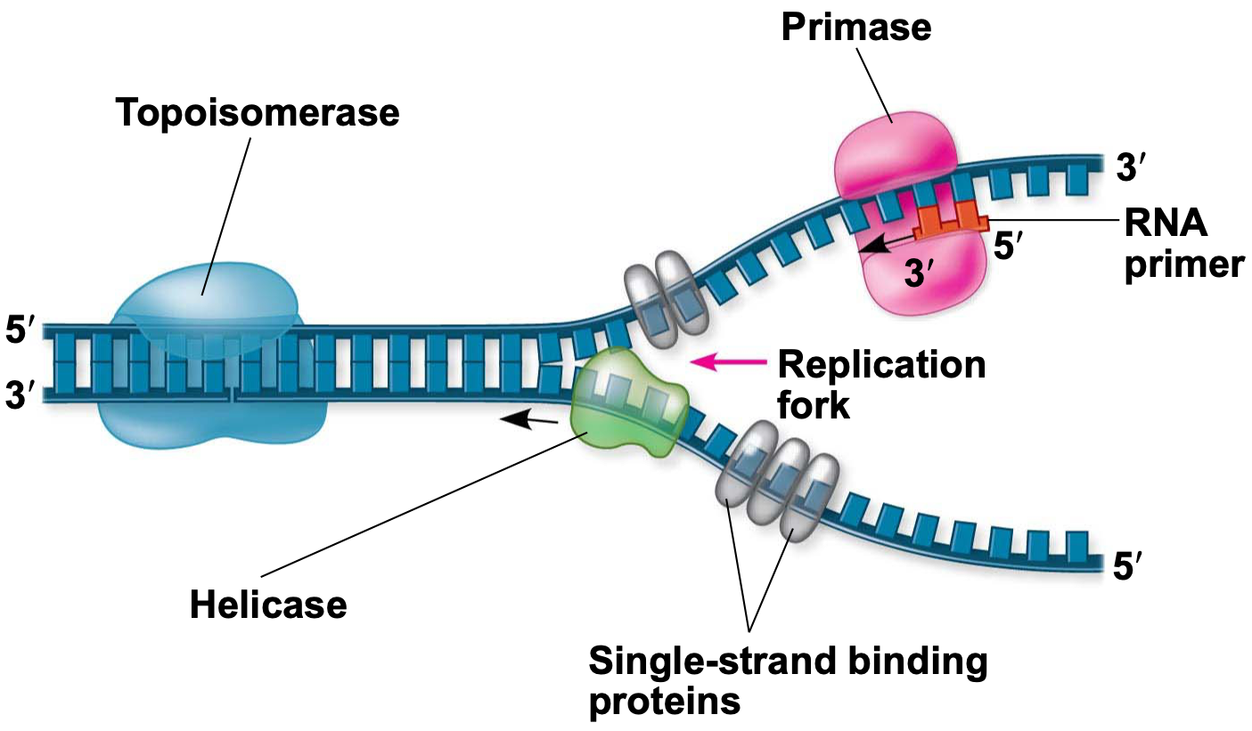
BIO 110: Integrative Biology 1
Fall 2022

Dr. Jennifer Larimore
Website: ilovebrains.org
LinkedIn: Jennifer Larimore
Email: jlarimore@agnesscott.edu
Office: 201 West BSC
Office hours: Mondays and Thursdays 1PM – 2PM or by appointment

SYLLABUS OUTLINE:
- Course Description and Textbook
- Success Plan
- Course and Skill Objectives (what you gain from the course)
- Grade Breakdown
- Course Overview
  - Reading
  - Lectures
  - Study Guides
  - Mastering Biology
  - Tests
  - Hidden Figures Presentation
- Academic Honesty
- Class Management

1. COURSE DESCRIPTION:
In this course, we will explore a number of core topics in biology including biochemistry, cell biology, genetics, gene expression, evolution, and ecology. Because biologists are discovering new things every day, we have selected some of the most significant topics to cover in this course.

Tuesday & Thursday 11:40 – 12:50

Essential course materials and Textbook:
- Biology in Focus, Second Edition, Person Publishing, by Lisa A. Urry, Michael L. Cain, Steven A. Wasserman, Peter V. Minorsky, Jane B. Reece. ISBN-13: 978-0321962751 | ISBN-10: 0321962753. This text is also used for Biology 111.
- Mastering Biology access (comes with a new textbook purchase) for Pearson. This will also be used in Biology 111. YOU MUST HAVE ACESS THE ENTIRE SEMESTER TO MASTERING BIOLOGY WITH YOUR AGNES SCOTT EMAIL ADDRESS.

Set up your Mastering Biology log in BEFORE the first day of class
1. Log in to Canvas and open your Canvas course.
2. Select a MyLab and Mastering link in Course Navigation on the left.
3. Select Open MyLab & Mastering to go to the course home page or select a link under Student Links.
Next, get access to your course content
- Sign in to link your Pearson and Canvas accounts. If you're new to MyLab and Mastering, create an account.
- Select any available access option, if asked.
  - Enter a prepaid access code that came with your textbook or from the bookstore.
  - Buy instant access using a credit card or PayPal account.
  - Select Get temporary access without payment for 14 days.
- Select Go to my course.
We recommend you always enter your Mastering Biology course through Canvas.
Need help? Make sure your browser is ready. Check the system requirements at https://mlm.pearson.com/global/system-requirements/

For help with Mastering for Canvas, go to https://help.pearsoncmg.com/integration/cg/canvas/student/en/

Or email Pearson for support.

- PowerPoints as well as other important information will be posted to Canvas. MP3s for the lecture will be available through the Google Drive folder for this class.
- In order to access the Google drive folder, you must be using an Agnes Scott email address.
- Canvas and Google Calendar: You can access the calendar in Canvas. And that calendar can be shared with your Google Calendar. There is a discussion board where you can use the class to answer questions or get in touch with the professor. The modules contain each of the pieces of the course. The syllabus item lets you see this syllabus and the schedule.
  - See instructions here: https://community.canvaslms.com/t5/Student-Guide/How-do-I-subscribe-to-the-Calendar-feed-using-Google-Calendar-as/ta-p/535
- Technology: You are required to have access to a computer or tablet. Cell phones should be in the silence mode prior to entering the classroom or lab. They should not be out/visible during class time. IF you are on your phone, you will be asked to leave and will not be allowed to make up any points missed.

2. SUCCESS PLAN:
Purpose and Plan: Why are you taking this class? What purpose does this class serve for you? What are your personal goals for this class? What will it take to achieve these goals?

You need to be able to answer these questions for each class you take – because the work will get hard and you will need to remind yourself what you are aiming for at the end of the semester.

Set your goal and then make a plan to achieve that goal. Post that goal in your course text or notebook.

Good Habits: Learning throughout the semester: Preparing for tests and actually learning the material in Bio 110 and every other class you’ll take, for that matter is made infinitely easier and more enjoyable if you establish an organized system for approaching the lecture and reading material early on in the semester.

SCHEDULE time and STICK to it: Based on assignments for both lecture and lab, you will spend 8-10 hours studying for this class outside of class time. Please come see your instructor early in the semester if you are struggling.

The lecture portion of Biology 110 is a 3 credit course. Additionally, you need to be co-enrolled in the 1 credit Biology 110 lab.

3. COURSE OBJECTIVES:

The American Association for the Advancement of Science described the concepts and competencies that form the necessary foundation for all science majors.

Concepts 1. Evolution 2. Structure and Function 3. Information flow, exchange, and storage 4. Pathways & transformations of energy and matter and 5. Systems Competencies 1. Apply the process of science 2. Use quantitative reasoning 3. Use modeling and simulation 4. Tap into the interdisciplinary nature of science 5. Communicate and collaborate with other disciplines and 6. Understand the relationship for science and society

Skill Objectives Skills you will gain from this course that advance your development as a scientist (and you can put on your CV and personal statements).
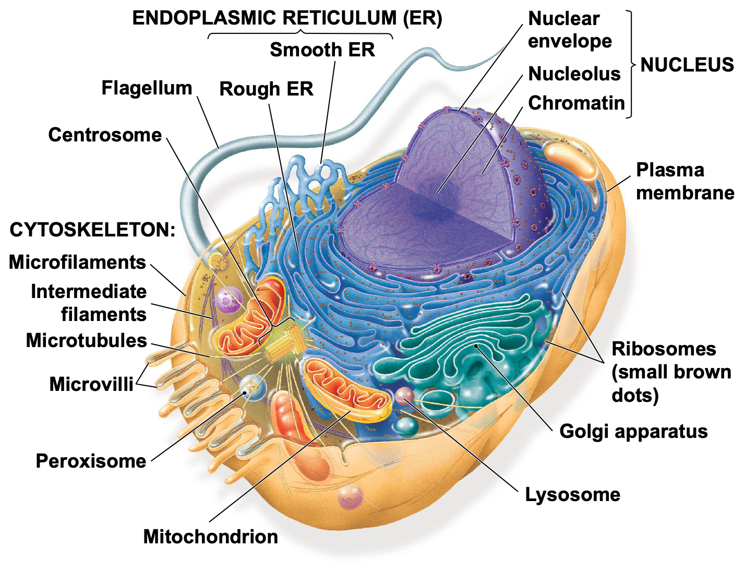
- Critical thinking/Problem Solving – through weekly application of knowledge and analyzing papers, students will think critically about potential solutions to scientific questions.
- Written Communication – through the final project, and in class assignments, students will develop the ability to write scientifically.
- Teamwork/Collaboration – working with a team for in class assignments will enable the students to practice real-world teamwork and leadership competencies that are taught as a part of SUMMIT.
- Digital Technology – students will learn how to navigate various online resources to complete assignments and collaborate with peers. Students will actively use Canvas, PubMed, Google Drive and Power point.

4. GRADES:
Your grades will be posted to Canvas regularly so you are aware of your standing in the course. Your final grade will be calculated using the following point breakdown:

Syllabus Study Guide 10 points
Career Management Study Guide 15 points
Unit Study Guides 80 points
Mastering Bio. Dynamic Module 130 points
Mastering Biology In Class Work 120 points
Test Points 140 points
Hidden Figures Presentation 40 points
Cum. Final Exam 100 points

The following grading scale will apply for converting numerical grades into final letter grades:
93 to 100: A, 90 to 92.9: A-, 87 to 89.9: B+, 83 to 86.9: B, 80 to 82.9: B-, 77 to 79.9: C+, 73 to 76.9: C, 70 to 72.9: C-, 67 to 69.9: D+ , 63 to 66.9: D, 60 to 62.9: D-, Lower than 60: F

**your grade is not weighted. Your grade is calculated by total points earned divided by totals points possible, multiplied by 100.

5. COURSE OVERVIEW:

A. READ BEFORE CLASS: the assigned chapter and papers (see syllabus schedule). The chapter will contain material that is explained differently and supports the lecture.

Read and take notes on the chapter (not just highlight). Hand-written notes will allow you to retain the information more than highlighting or simply reading. Bring those notes to class.

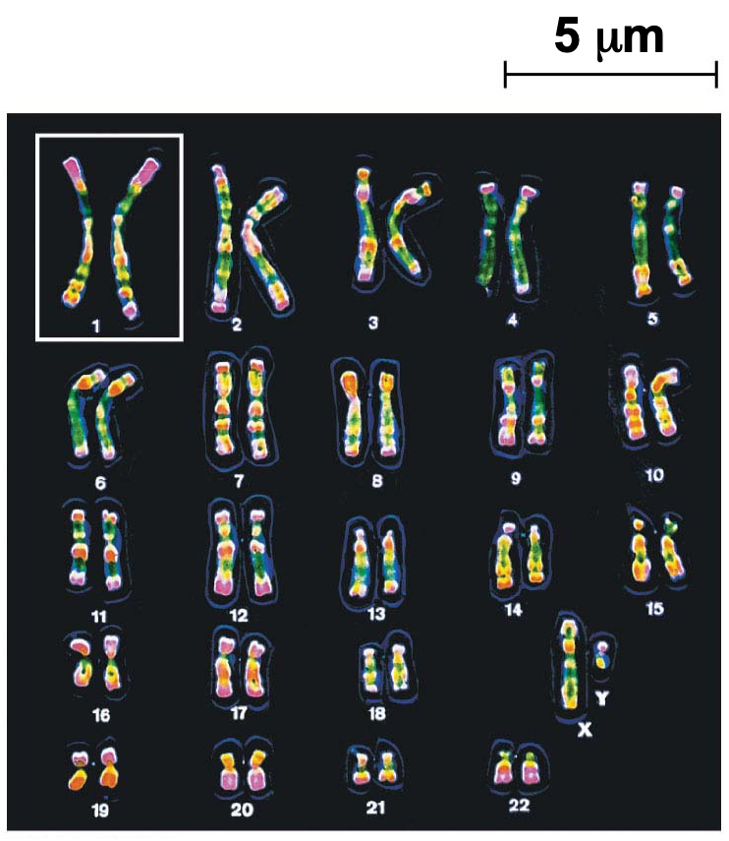
B. LISTEN TO LECTURE BEFORE CLASS: Listen to the recorded lecture for that material BEFORE coming to class for that topic.

You may find that listening to the lecture before reading the chapter serves you best. Either way, the lecture PDFs are available on Canvas by Unit. Use these to guide your notes.

The in class time will spent on how to apply the knowledge. This is your education. You are responsible for using the material given to you and figuring out how best to learn the information. To succeed, you cannot memorize this information. You must actively learn.

C. STUDY GUIDES in CLASS WORK: are meant to practice and apply what was learned in the lecture. Study Guides have several parts: Concept maps, and the Article Analysis. See Canvas for due dates.

D. MASTERING BIOLOGY BEFORE AND DURING CLASS: Mastering Biology is an online platform that will deliver quizzes (dynamic modules) BEFORE class.

We will also use Mastering Biology for application material in class assignments. You will be required to have access for this semester and next semester.

Set up your Mastering Biology log in BEFORE the first day of class
1. Log in to Canvas and open your Canvas course.
2. Select a MyLab and Mastering link in Course Navigation on the left.
3. Select Open MyLab & Mastering to go to the course home page or select a link under Student Links.
Next, get access to your course content
- Sign in to link your Pearson and Canvas accounts. If you're new to MyLab and Mastering, create an account.
- Select any available access option, if asked.
  - Enter a prepaid access code that came with your textbook or from the bookstore.
  - Buy instant access using a credit card or PayPal account.
  - Select Get temporary access without payment for 14 days.
- Select Go to my course.
We recommend you always enter your Mastering Biology course through Canvas.
Need help? Make sure your browser is ready. Check the system requirements at https://mlm.pearson.com/global/system-requirements/

For help with Mastering for Canvas, go to https://help.pearsoncmg.com/integration/cg/canvas/student/en/

Or email Pearson for support.

E. TESTS will consist of multiple choice and short-answer questions that evaluate your knowledge. They will be application questions. There are 4 tests for this course (one for each unit of study) and one final exam. The final exam will be cumulative. See schedule for test dates.

F. HIDDEN FIGURES PRESENTATION. You find details about this assignment on the Canvas module for this assignment. This will be a group presentation.

6. ACADEMIC HONESTY FOR YOUR WORK AS A SCIENTIST:
You are responsible. Review each course syllabus for the professor’s expectations regarding course work and class attendance. Violations of the honor code will result from failure of the assignment, failure of the course, to expulsion from the college.

Do not cut and paste from the slide, your book, your neighbor, Wikipedia, or the internet. To further your science education, you need to be able re-word science in your own voice. If your answers are not your own, you will receive a 0 for the assignment.

All cases of academic dishonesty will be turned into Honor Court. By placing your name on ANY assignment, you are stating that you completed that assignment with academic honesty.

Academic dishonesty is reported to medical schools and graduate schools as per their request. Anyone caught cheating relinquishes the privilege of asking for a letter of recommendation from the professor and will receive a 0 on the assignment.

Plagiarism: Plagiarism can include portraying another’s work or ideas as your own, buying a paper online and turning it in as if it were your own work, or not citing or improperly citing references on a reference page or within the text of a paper.

Passing off someone else’s work as your own represents intellectual fraud and theft, and violates the core values of our academic community. Putting a citation behind a statement gives ownership to that source, but, if you do not reword that information, it is plagiarism.

Intellectual Fraud: do not falsify or create data and resources or alter a graded work without the prior consent of your professor.

Cheating: do not allow another party to do your work/exam, or submit the same or similar work in more than one course without permission from the course instructors. Cheating also includes taking an exam for another person, looking on another person’s exam for answers, using exams from previous classes without permission, or bringing and using unauthorized notes or resources (i.e., electronic, written, or otherwise) during an exam.

7. CLASS MANAGEMENT:
Email/Canvas: Instructors will make announcements regularly via email. It is your responsibility to check your Agnes Scott email account daily. When responding to a professor via email, take care that your email is professional.

You can access the calendar in Canvas. And that calendar can be shared with your Google Calendar. There is a discussion board where you can use the class to answer questions or get in touch with the professor. The modules contain each of the pieces of the course. The syllabus item lets you see this syllabus and the schedule.

Technology: Cell phones should be in the silence mode prior to entering the classroom or lab.

Course Accessibility and Academic Accommodations. Agnes Scott College views disabilities as an integral part of the rich diversity of our community and strives to make all learning experiences as accessible as possible. If you are a student who receives academic accommodations through the Office of Accessible Education, please schedule a meeting with your instructor within the first two weeks of classes to discuss how your accommodations will be implemented for this course. During this meeting, you are not expected to disclose any details concerning your disability, though you may discuss these details at your discretion.

Title IX: Agnes Scott is here to help you if you have experienced any form of sexual harassment or violence, dating or domestic violence, or stalking. Please talk to any faculty or staff member with whom you feel comfortable. Faculty and staff members want to support you and have been trained to help. They will also inform the Title IX office so that you learn about options available to you. If you do not want college administrators to know what you have experienced, you may talk to the chaplain, as well as nurses or counselors in the Wellness Center with complete confidentiality. They will not tell anyone what you share with them unless you give your express permission. You may contact the Title IX Coordinator directly at T9Coordinator@agnesscott.edu.

Inclusion: Please include this statement or a version of it in your syllabus. Agnes Scott is a diverse and inclusive community.

As one of the most diverse colleges in the nation, ASC is ideally positioned to be the model of a diverse and inclusive community that society can aspire to be. Such diversity raises the intellectual quality of the classroom experience, creating a unique environment for learning to understand and navigate the challenges of our times.

By studying, living, and playing together, Agnes Scott College’s remarkably diverse student body hones the habits of mind, skills, and knowledge essential to ethical and innovative leadership in our increasingly heterogeneous and global society.

As such, this course adheres to the principles of diversity and inclusion as integral to the Agnes Scott community and respects people from all backgrounds. As a first step, this course affirms people’s decisions about gender expression and identity and will use each other’s preferred names and gender pronouns at all times.

Content warning: This course will explore cell biology, genetics, ecology and evolution, which might raise issues of racism, sexism, classism, heterosexism, cissexism, ableism, and other kinds of privilege. I invite you to come see me if want more information. If you feel you will be unable to fully participate in the course requirements, set up a meeting with the course instructor to determine appropriate accommodations.

Date | Class Topic | BEFORE Class: Read and Listen | DUE at the end of class
TR 8/25 | Syllabus  - in class group work on the study guide for the syllabus  - group agreements  - work on plag. Article | - Syllabus  - Kumar https://www.ncbi.nlm.nih.gov/pmc/articles/PMC4212376/ | - Group turn in off syllabus study guide
UNIT 1: BIOLOGY BASICS
Chapter 2, 3, and 4

T 8/30 | Chemistry of Biology  - lecture review  - lecture Q and A  - in class group work on Mastering Biology (MB)  - Article Work  - Concept Map Work  - Career Management Study Guide | - Campbell Chapter 2  - https://www.huffpost.com/entry/how-to-read-and-understand-a-scientific-paper_b_5501628 | - Individual completion of MB in class work
TH 9/1 | Biological Molecules  - lecture review  - lecture Q and A  - in class group work on Mastering Biology (MB)  - Article Work  - Concept Map Work | - Campbell Chapter 3  - https://kb.gcsu.edu/cgi/viewcontent.cgi?article=1024&context=undergraduateresearch | - Individual completion of MB in class work
T 9/6
No class because of Labor day
TH 9/8 | Biological Molecules  - lecture review  - lecture Q and A  - in class group work on Mastering Biology (MB)  - Article Work  - Concept Map Work | - Campbell Chapter 3  - https://kb.gcsu.edu/cgi/viewcontent.cgi?article=1024&context=undergraduateresearch | - Individual completion of MB in class work
T 9/13 | The cell  - lecture review  - lecture Q and A  - in class group work on Mastering Biology (MB)  - Article Work  - Concept Map Work | - Campbell Chapter 4  - https://kb.gcsu.edu/cgi/viewcontent.cgi?article=1024&context=undergraduateresearch | - Individual completion of MB in class work
TH 9/15 | The cell  - lecture review  - lecture Q and A  - in class group work on Mastering Biology (MB)  - Article Work  - Concept Map Work | - Campbell Chapter 4  - https://kb.gcsu.edu/cgi/viewcontent.cgi?article=1024&context=undergraduateresearch | - Individual completion of MB in class work  - Unit study guide uploaded as a group assignment
T 9/20
Test #1 on unit 1 & assigned readings

UNIT 2: The Cellular Functions
Chapters 9, 10, 13, and 14

TH 9/22 | Cell cycle and Cell Cycle Regulation  - lecture review  - lecture Q and A  - in class group work on Mastering Biology (MB)  - Article Work  - Concept Map Work  - Career Management Study Guide | - Campbell Chapter 9  - https://www.ncbi.nlm.nih.gov/pmc/articles/PMC6723681/ | - Individual completion of MB in class work
T 9/27 | Meiosis  - lecture review  - lecture Q and A  - in class group work on Mastering Biology (MB)  - Article Work  - Concept Map Work | - Campbell Chapter 10  - https://www.ncbi.nlm.nih.gov/pmc/articles/PMC6723681/ | - Individual completion of MB in class work
TH 9/29 | Meiosis  - lecture review  - lecture Q and A  - in class group work on Mastering Biology (MB)  - Article Work  - Concept Map Work  - Career Management Study Guide | - Campbell Chapter 10  - https://www.ncbi.nlm.nih.gov/pmc/articles/PMC6723681/ | - Individual completion of MB in class work
T 10/4 | DNA replication and structure  - lecture review  - lecture Q and A  - in class group work on Mastering Biology (MB)  - Article Work  - Concept Map Work | - Campbell Chapter 13  - https://www.ncbi.nlm.nih.gov/pmc/articles/PMC6723681/ | - Individual completion of MB in class work
TR 10/6 ~ no Class ~ Fall Break
T 10/11 | DNA replication and structure  - lecture review  - lecture Q and A  - in class group work on Mastering Biology (MB)  - Article Work  - Concept Map Work | - Campbell Chapter 13  - https://www.ncbi.nlm.nih.gov/pmc/articles/PMC6723681/ | - Individual completion of MB in class work
TR 10/13 | Transcription and Translation  - lecture review  - lecture Q and A  - in class group work on Mastering Biology (MB)  - Article Work  - Concept Map Work | - Chapter 14  - https://www.ncbi.nlm.nih.gov/pmc/articles/PMC6723681/ | - Individual completion of MB in class work  - Unit study guide uploaded as a group assignment
T 10/18
Test #2 on unit 2
UNIT 3: Genetics
Chapters 11, 12, and 19
TH 10/20 | Mendelian Genetics  - lecture review  - lecture Q and A  - in class group work on Mastering Biology (MB)  - Article Work  - Concept Map Work  - Career Management Study Guide | - Campbell Chapter 11  - https://pubmed.ncbi.nlm.nih.gov/11222644/ | - Individual completion of MB in class work
T 10/25 | Extensions of Mendelian Genetics  - lecture review  - lecture Q and A  - in class group work on Mastering Biology (MB)  - Article Work  - Concept Map Work  - Career Management Study Guide | - Campbell Chapter 11  - https://pubmed.ncbi.nlm.nih.gov/11222644/ | - Individual completion of MB in class work
TH 10/27 | Chromosomal Basis of Inheritance, Gene Linkage and abnormalities  - lecture review  - lecture Q and A  - in class group work on Mastering Biology (MB)  - Article Work  - Concept Map Work  - Career Management Study Guide | - Campbell Chapter 12 and  - https://pubmed.ncbi.nlm.nih.gov/11222644/ | - Individual completion of MB in class work
T 11/1 | Descent with modification  - lecture review  - lecture Q and A  - in class group work on Mastering Biology (MB)  - Article Work  - Concept Map Work  - Career Management Study Guide | - Campbell Chapter 19  - https://pubmed.ncbi.nlm.nih.gov/11222644/ | - Individual completion of MB in class work
TH 11/3 | Descent with modification  - lecture review  - lecture Q and A  - in class group work on Mastering Biology (MB)  - Article Work  - Concept Map Work  - Career Management Study Guide | - Campbell Chapter 19  - https://pubmed.ncbi.nlm.nih.gov/11222644/ | - Individual completion of MB in class work  - Unit study guide uploaded as a group assignment
T 11/8
Test #3 on unit 3
UNIT 4: Ecology
Chapters 40,41, and 42

TH 11/10 | Population Ecology  - lecture review  - lecture Q and A  - in class group work on Mastering Biology (MB)  - Article Work  - Concept Map Work  - Career Management Study Guide | - Campbell Chapter 40  - https://pubmed.ncbi.nlm.nih.gov/30740637/ | - Individual completion of MB in class work
T 11/15 | Species Interactions  - lecture review  - lecture Q and A  - in class group work on Mastering Biology (MB)  - Article Work  - Concept Map Work  - Career Management Study Guide | - Campbell Chapter 41  - https://pubmed.ncbi.nlm.nih.gov/30740637/ | - Individual completion of MB in class work
TH 11/17 | Ecosystems and Energy  - lecture review  - lecture Q and A  - in class group work on Mastering Biology (MB)  - Article Work  - Concept Map Work  - Career Management Study Guide | - Campbell Chapter 42  - https://pubmed.ncbi.nlm.nih.gov/30740637/ | - Individual completion of MB in class work  - Unit study guide uploaded as a group assignment
T 11/22
Test #4 on unit #4
11/23-11/27
No Class - Thanksgiving Break

T 11/29 | Hidden Figures Presentation | Hidden Figures Presentation | Hidden Figures Presentation
TH 12/1 | Review Day  - We will review tests and assignments for the final |  | - Bring any questions you may have
T 12/6
Reading Day
12/7 - 12/12
Final Exam Days

